On Demand App :Nearby Service Provider



**ABSTRACT**

In today’s digital era, where speed and convenience drive user preferences, On-Demand Applications have become essential tools in bridging the gap between service providers and consumers. This project presents an innovative **“On-Demand Service Provider App”** that empowers users to locate and hire nearby service professionals—such as plumbers, electricians, mechanics, beauticians, and others—directly from their smartphones. The application focuses on eliminating the hassle of searching for trusted providers by offering a centralized platform that connects users with vetted, reliable professionals based on location, service category, and availability.

Customers can easily browse service categories, compare pricing, read reviews, and book services—all with just a few taps. Users can also easily interact with shops, purchase products, and make payments effortlessly through the app. Simultaneously, service providers gain a dynamic platform to showcase their offerings, manage customer requests, and expand their visibility. The system ensures transparency in pricing, timing, and quality assurance by incorporating features such as real-time location updates, ratings, and service history tracking.

By reducing manual effort, streamlining communication, and ensuring a quality experience, the proposed On-Demand Service App redefines how users connect with essential services, making everyday tasks more efficient and stress-free.

**Feasibility Study Analysis**

**1. Project Description**

In today’s fast-paced world, users expect services to be accessible instantly and conveniently. The proposed “On-Demand Service Provider App” is a mobile and web-based solution that connects users with nearby, verified professionals like plumbers, electricians, beauticians, mechanics, etc., via a single platform.

The system enhances the user experience by integrating real-time geolocation tracking, service comparisons, and secure payments, while giving service providers the tools to manage requests, showcase portfolios, and grow their client base.

**2. Core Features**

**Geolocation (Maps API Integration)**

* Auto-detect user's location.
* Show nearby available service providers.
* Real-time tracking of service delivery.

**Machine Learning**

* Predict user needs based on past searches and behavior.
* Suggest services, predict pricing based on location/time.

**Internet of Things (IoT) Integration**

* Real-time updates of service provider movement.
* Smart alerts when a service provider is approaching.

**3.Market Feasibility**

**Market Demand:**

* There is a growing demand for fast, reliable, and easily accessible home and personal services in urban and semi-urban areas.
* With increasing smartphone penetration and busy lifestyles, users prefer booking services online instead of traditional phone calls or offline searches.
* Post-COVID-19 behavior changes have increased dependency on digital platforms for essential services like sanitization, plumbing, home repairs, grooming, etc.
* The on-demand home service market in India is projected to reach $3.5 billion by 2025, growing at a CAGR of 18–20%.
* Users increasingly expect features like real-time tracking, verified professionals, and

cashless payment options.

**4.Economic Feasibility – Project Description**

The economic feasibility of the **On-Demand Service Provider App** evaluates whether the proposed system can be developed and operated at a cost that is justified by the expected benefits. This app will connect customers with nearby service providers such as plumbers, electricians, cleaners, and technicians, allowing for quick booking, secure payment, and reliable service delivery.

From a financial perspective, the project requires an initial investment for **design, development, infrastructure setup, and marketing**. which includes app development, cloud hosting, third-party integrations (such as payment gateways and maps), and the first year of operations.

The revenue model is based on multiple income streams, such as **commission from service providers, subscription plans, advertisements, and lead generation fees**. These revenue sources are projected to generate an average of **₹3.4 lakh to ₹7.3 lakh per month** in the early stages, with potential for significant growth as the platform expands to multiple cities.

While there are risks, such as competition and the challenge of acquiring an initial user base, these can be mitigated through strategic marketing, partnerships with local service providers, and the implementation of unique features like **AI-driven service recommendations** and **secure blockchain-based provider verification**.

## ****5. Technical Feasibility****

This project involves building a full-stack mobile/web application that connects users with local service providers. The system includes modules for users, service providers, and administrators, and incorporates advanced features like geolocation, real-time tracking, machine learning recommendations, and secure authentication.

**Technology Stack**

| **Layer** | **Technology Used** |
| --- | --- |
| Frontend | Flutter |
| Backend | Firebase |
|  |  |
| Location | Maps API / Geolocation API |
| AI/ML | Python-based microservices via APIs |
| IoT/GPS | Mobile device sensors for real-time tracking |

**6. System Requirements & Feasibility**

**Development Tools Availability**

* All development tools (Flutter, Firebase) are **open-source** and widely supported.
* IDEs like VS Code and Android Studio testing make development easier.

**Geolocation Integration**

* Feasible using **Maps API**.
* Mobile devices natively support location tracking (via GPS).

**Machine Learning Implementation**

* Feasible via lightweight ML models hosted as microservices.
* Can handle tasks like user preference prediction and price estimation.

**IoT & Real-Time Tracking**

* Real-time tracking of service providers can be implemented using:
  + WebSockets or Firebase Realtime Database
  + Native GPS modules in smartphones (no extra hardware needed)

## 7. Existing Solution

In the existing system, it can be difficult to find nearby services when needed. Users struggle to find reliable service providers, increasing manual work and difficulty in identifying service details.

## 8. Disadvantages of Existing System

* Some users may prefer traditional methods like word-of-mouth or online searches.
* Risk of encountering unreliable or unsatisfactory services despite vetting.
* Limited availability of the app in all areas.

## 9. Proposed Solution

The proposed system offers convenience. Instead of calling multiple providers, users can browse a list of vetted professionals in the app, saving time and ensuring service quality.

## 10. Advantages of Proposed System

* Easy and quick service search, saving time and effort.
* High-quality services ensured through provider vetting and user rating system.
* Wide range of services, from plumbers to electricians,mechanics, easily accessible.

## 11. System Modules

### Servicer

* Registration
* Login
* My Profile
* Create Services (Name, Price, Category, Description,Service Images,Portfolio Image)
* Update/Delete Services
* My Service Requests (Accept or Reject, View User Map Location)

### customer

* Registration
* Login
* My Profile
* Search Nearby Services
* Send Request
* My Request
* Update Geo Location
* Make Payment
* Check Status

### Admin

* Login
* Manage Services
* Approve New Services
* Manage Users
* View Services
* Logout

## Module Description

### Servicer

* **Register** – Enter basic details to access the application.
* **Login** – Login to use the app.
* **Create Services** – Add service name, price, category, description, images, and links.
* **Update/Delete Services** – Modify or remove services.
* **My Service Request** – Manage incoming requests; accept/reject and view user location.
* **My Profile** – Update personal service provider profile.

**Administrator**

* + **Login –** Access admin functionalities
  + **Profile**
  + **Manage Sellers –** Approve and manage seller details.
  + **Manage Users –** View and manage registered users.
  + **View Services –** View all services posted by providers.

**Customer**

* **Register** – Sign up for the application.
* **Login** – Access app features after registration.
* **Search Nearby Services** – Find providers based on proximity.
* **My Request** – Request service, update location, and check status.
* **My Profile** – Manage user account information.

**Database Structure**

**1. Customer Table**

| **Field Name** | **Type** | **Description** |
| --- | --- | --- |
| customer_id (PK) | ObjectId | Unique identifier |
| Name | String | User full name |
| Email | String | User email (unique) |
| password | String | Hashed password |
| phone | String | Mobile number |
| location | String | Address or coordinates |

**Primary Key: user_id**

**2. Service_Providers Table**

| **Field Name** | **Type** | **Description** |
| --- | --- | --- |
| provider_id (PK) | ObjectId | Unique identifier |
| Name | String | Provider name |
| Email | String | Email address |
| password | String | Hashed password |
| Phone | String | Contact number |
| Category | String | General category (plumber, etc.) |
| Location | String | Provider’s operating area |
| portfolio_image | String | Optional image URL |

**Primary Key: provider_id**

**3. Services Table**

| **Field Name** | **Type** | **Description** |
| --- | --- | --- |
| service_id (PK) | ObjectId | Unique ID for the service |
| provider_id (FK) | ObjectId | Links to provider |
| Name | String | Service title |
| category | String | Plumbing, Electrical, etc. |
| description | String | Service details |
| Price | Number | Price in INR |
| Images | Array | Image URLs |

**Primary Key: Service_id  
Foreign Key: Provider_id → service_providers.provider_id**

**4. Service_requests Table**

| **Field Name** | **Type** | **Description** |
| --- | --- | --- |
| request_id (PK) | ObjectId | Unique ID of the service request |
| user_id (FK) | ObjectId | Who made the request |
| service_id (FK) | ObjectId | Requested service |
| Status | String | Pending / Accepted / Completed |
| requested_time | DateTime | Timestamp of request |
| location | String | Service location |

**Primary Key: request_id  
Foreign Keys:**

* **customer_id → customer(customer_id)**
* **service_id → services(service_id)**

**5. Admin Table**

| **Field Name** | **Type** | **Description** |
| --- | --- | --- |
| admin_id (PK) | ObjectId | Unique ID for admin |
| Email | String | Admin login email |
| password | String | Hashed password |

**Primary Key: admin_id**

**Payment Table**

| **Field Name** | **Data Type** | **Constraints / Description** |
| --- | --- | --- |
| payment_id | BIGINT (PK) | Unique identifier for the payment transaction. |
| request_id | BIGINT (FK) | References Request.request_id — links payment to a specific service request. |
| user_id | BIGINT (FK) | References User.user_id — who made the payment. |
| servicer_id | BIGINT (FK) | References Servicer.servicer_id — who is receiving the payment. |
| service_id | BIGINT (FK) | References Service.service_id — service being paid for. |
| amount | DECIMAL(10,2) | Total transaction amount. |
| currency | VARCHAR(10) | Currency code (e.g., "INR", "USD"). |
| payment_method | VARCHAR(50) | Method used: UPI, Credit Card, Debit Card, Wallet, Net Banking. |
| payment_status | ENUM('Pending', 'Completed', 'Failed', 'Refunded') | Current status of the payment. |
| transaction_id | VARCHAR(100) | Reference from payment gateway (Razorpay, PayPal, etc.). |
| payment_date | DATETIME | Date and time of payment. |
| remarks | TEXT | Optional notes (e.g., refund reason, dispute details). |

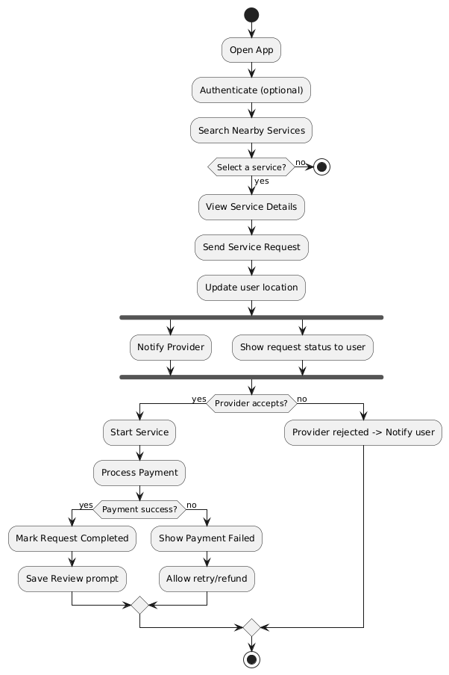**Activity Diagram**

**CLASS DIAGRAM**

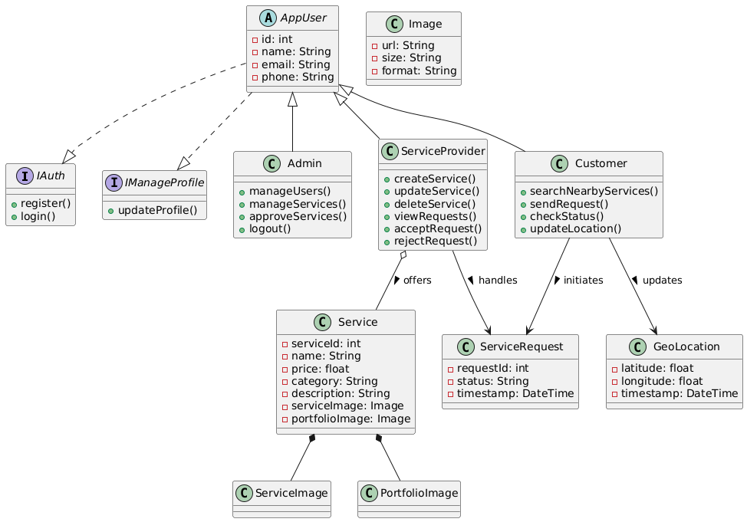

**Component Diagram**

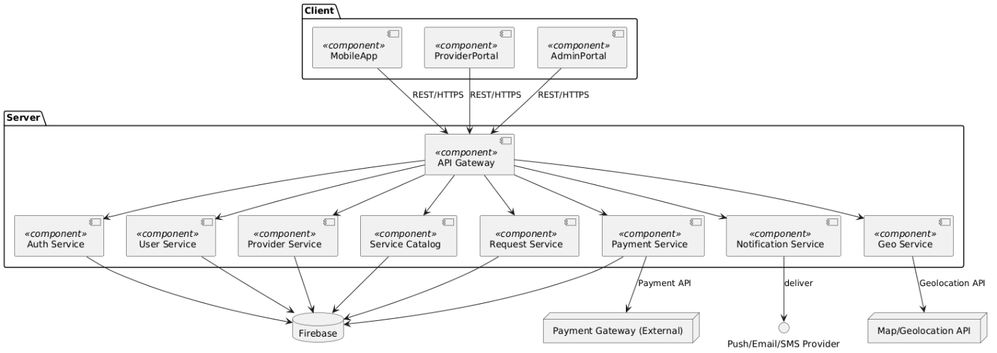

**Object Diagram**

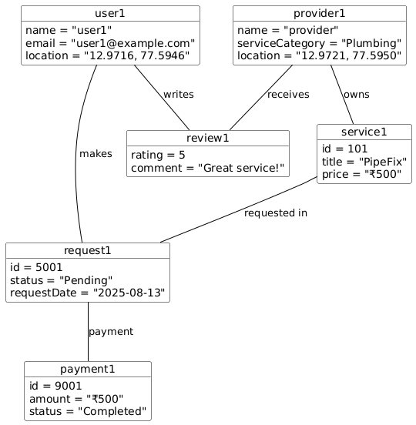

**Use Case Diagram  
  
User Module**

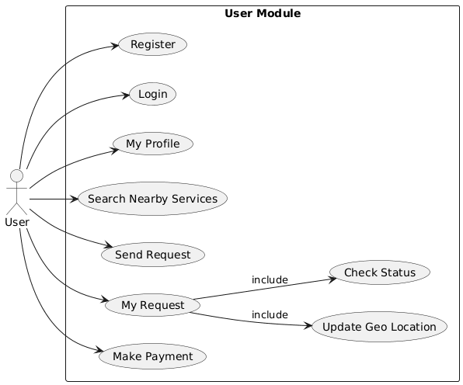

**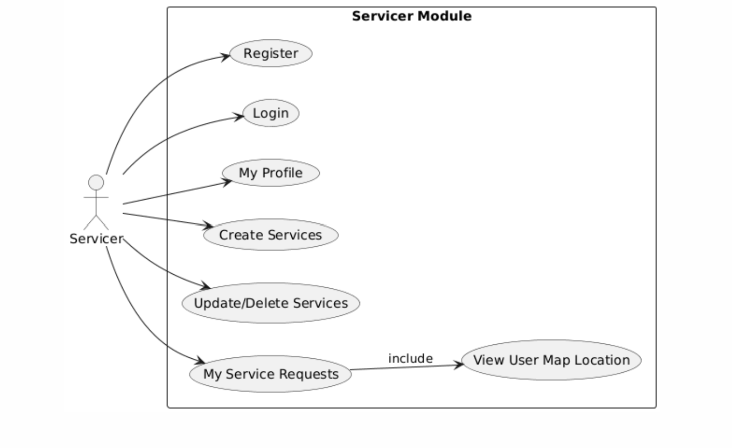   
Service Module**

**Admin Module**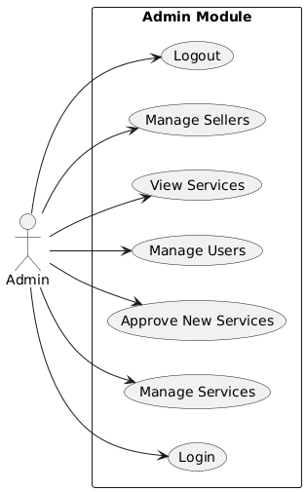

**11. Questions & Answers**

**Q1**. Would you be willing to register on an app to reach nearby customers?

Ans:Yes, it would help expand my customer base and reduce the time I spend looking for work.

**Q2**. Do you currently face difficulties in getting verified or genuine service requests?

Ans: Yes, many leads turn out to be fake or waste time. A verified app system would be very helpful.

**Q3**. Are you comfortable using a mobile app to manage your services and appointments?

Ans: Yes, I use apps like WhatsApp and PayTM, so using a service app would not be an issue.

**Q4**. What features would you like to see in such an app?

Ans: Set availability, receive service request notifications, view customer location, and manage

Rating.

**Q5.** Would having customer reviews and ratings on your profile affect your willingness to use the app?

Ans: No, I believe it builds trust. Good service always gets rewarded.

**Q6**. Would you pay a small commission or subscription fee for regular, genuine leads?

Ans: Yes, if the app guarantees genuine leads, I would be willing to pay a nominal fee.

**Q7**. How do you currently promote your service or find customers?

Ans: Mostly through word-of-mouth or local classifieds, but it’s limited in reach.

**Q8**. Do you have access to a smartphone and basic internet to use the app regularly?

Ans: Yes, I use a smartphone with mobile data daily.

**Q9**. Do you face challenges in navigating locations or reaching customers on time?

Ans: Yes, sometimes addresses are unclear. Live location from the app would really help.

**Q10**. Would you prefer cash payments or digital payments (UPI, PayTM, etc.) via the app?

Ans: I prefer digital payments as they are fast and easy to track, but cash option should also be available.

**Photos**



